18.18: From example 18.4, the pressure at elevation y above sea level is 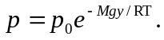 The average molar mass of air is 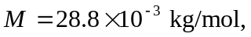so at an altitude of 100 m,

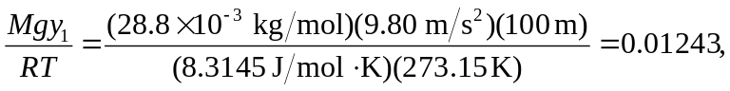

and the percent decrease in pressure is At an altitude of 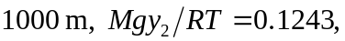 and the percent decrease in pressure is 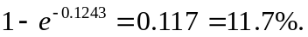 These answers differ by a factor of 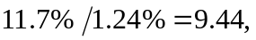which is less than 10 because the variation of pressure with altitude is exponential rather than linear.

